

Informatica Reverse Smart Connector

User Guide

Version 1.0

# 

Table of Contents

1. Introduction 3

1.1 Overview 3

1.2 Scope 3

1.3 Supported Operating Systems 3

2. Using the Connector 4

2.1 Connector Options 4

2.2 Configuring the Connector 5

2.3 Running the Connector 5

2.4 Scheduling the Connector 6

1. Introduction
   1. Overview

The Informatica Reverse Smart Connector is used to reverse engineer Informatica mapping and create mappings in Erwin Data Intelligence Suite (DIS). The Connector creates the mappings under individual Subject.

* 1. Scope
* The Connector requires the Informatica exported files in .xml format.
  1. Supported Operating Systems
* Windows
* Linux

# 

1. Using the Connector
   1. Connector Options

The connector provides the following options which can also be edited and saved prior to a connector run or can also be updated at run time. The Informatica Reverse connector provides the following options:

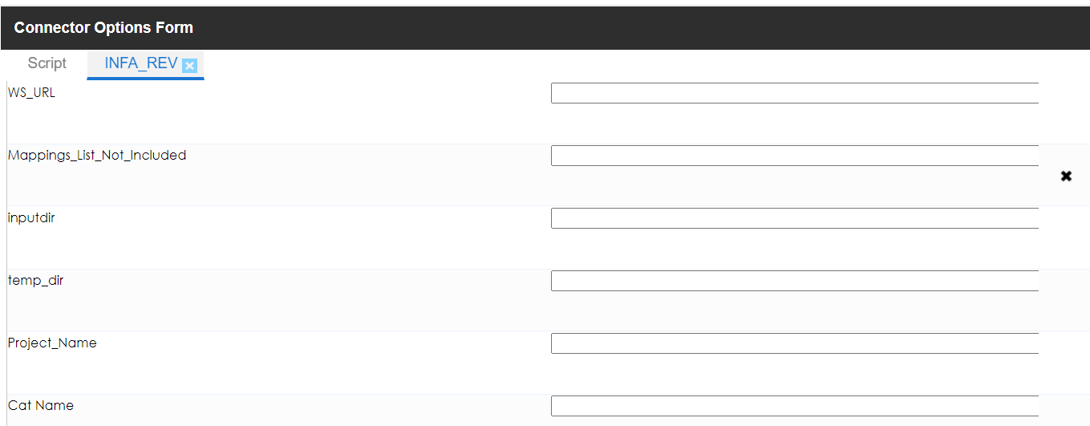

Fig: Informatica Reverse Connector Options

|  |  |
| --- | --- |
| * WS_URL | Please provide the INFORMATICA war web service URL Path. |
| * Mappings_List_Not_Included |  |
| * Inputdir | Provides the user an option to place the input files using the appropriate fields. |
| * temp_dir | Please provide the path for temp files to be placed under. |
| * Project Name | This field contains the name of the Project to be used in DIS.  If a project does not already exist, the Connector will create a new project.  If an existing project name is used, the connector will create the  mappings in the existing project. |
| * CAT Name | Provide the CAT Name. |

* 1. Configuring the Connector
* The field details for the connector can be updated by right clicking on the connector and clicking on “Options”, or by clicking on the gear icon under the Options column alongside the connector name.

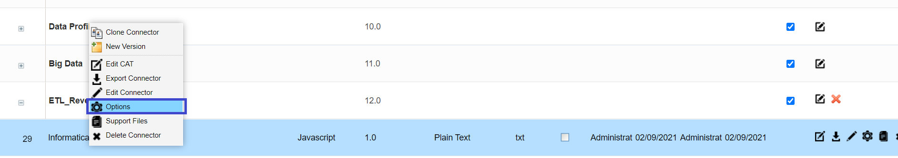

* 1. Running the Connector

The connector can be executed by following the steps below:

* Right click on the Project node in DIS Mapping Manager and click on “Run Template”.

­ 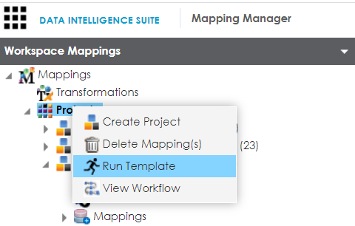

* On the next pop-up window Navigate to the Tab “**ETL Reverse Connectors**” and locate the connector “INFORMATICA_RE_v1.0.acp” in the Connector List and click on “Export”.

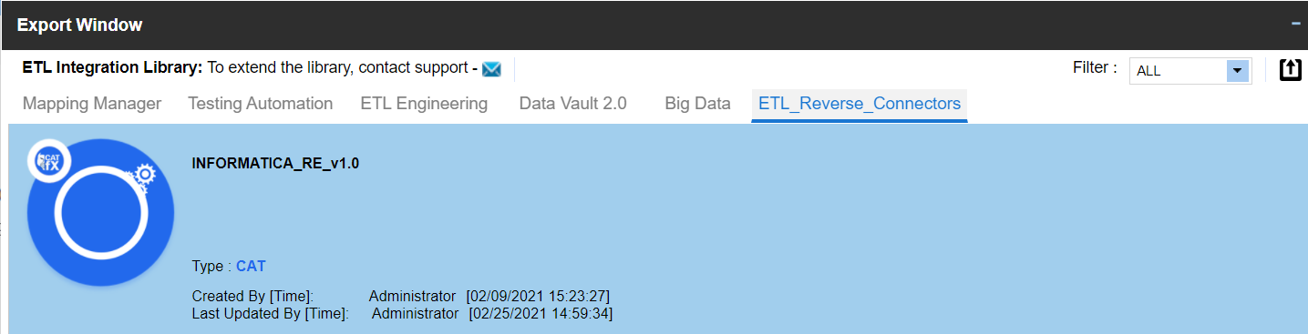

* On the next pop up window, enter the required details in the text fields as per the field descriptions in the section “2.1 Connector Options”.
* Click on the green check box in the top right corner to run the connector.

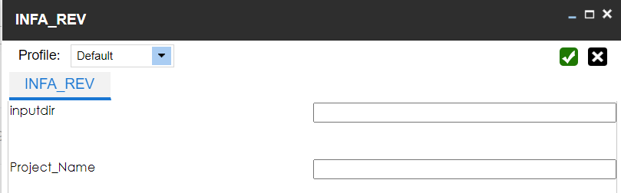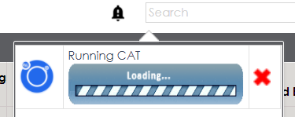

* Once the connector finishes execution, it provides a “Download File” option in the notifications pane.

This file will contain an information log on the mappings created/updated in DIS Mapping Manager.

* Refresh the browser window and under the Mapping Manager module, check for the project created on the left-hand side of the page under the Projects Node and verify if the mappings are created.

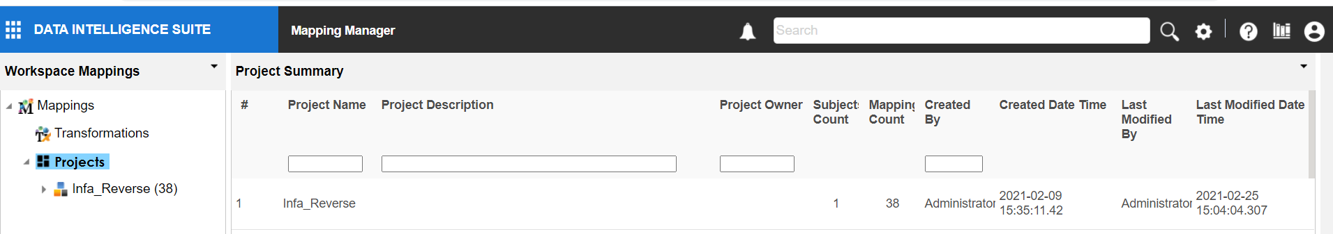

* 1. Scheduling the Connector
* The connector can also be scheduled to run at a specific point of time as a single run or configured to run at regular intervals of time.
* To schedule a connector run, navigate to the “Automation Framework” module, and click on the options icon of the Informatica Reverse Connector.
* When the “CAT Menu” window opens up, click on the “Options” button (the gear icon) and make sure the input parameters provided are correct.

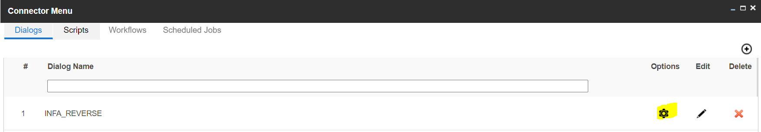

* Please create a workflow to run the JOB.

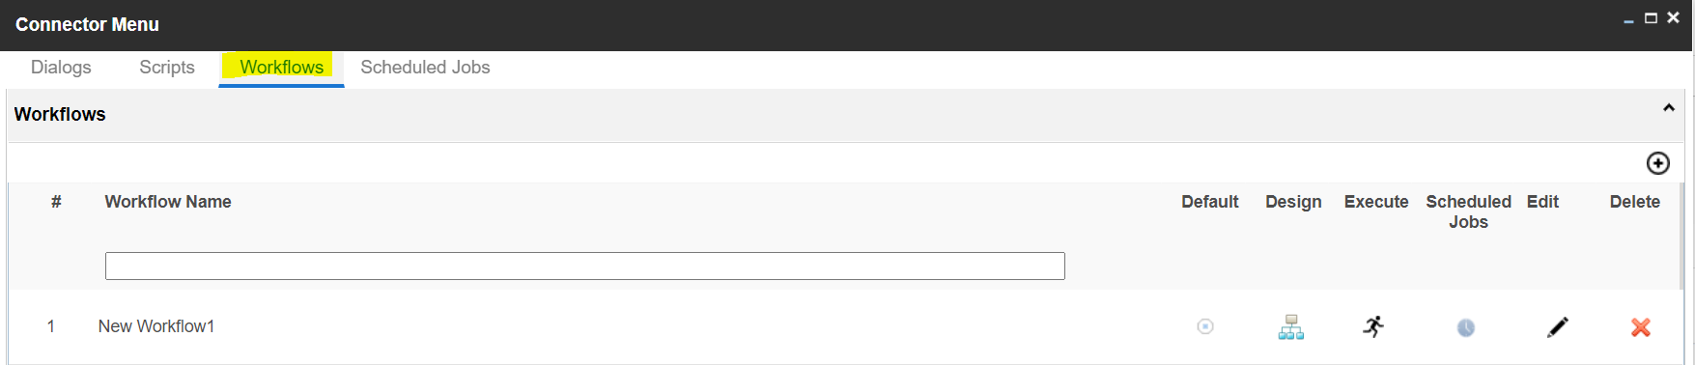

* Once the input parameters have been confirmed and saved, click on the “Scheduled Jobs” tab in the “CAT Menu Window” and click on the “+” icon on the right to create a new Scheduled Job.

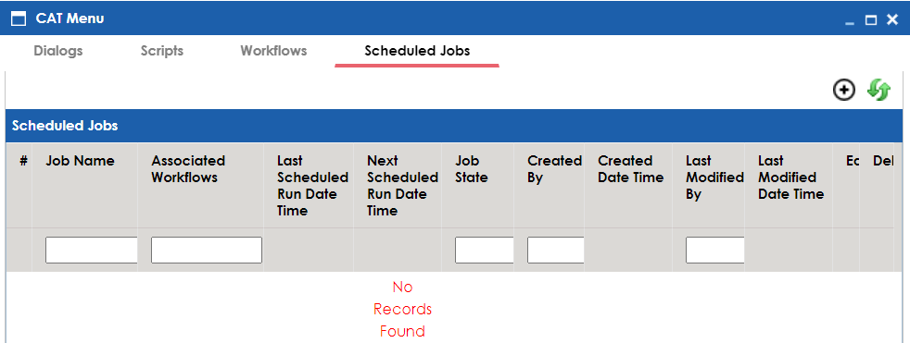

* In the Job Scheduler window, select the workflow from the dropdown.

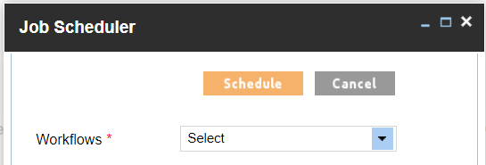

* Enter the time and Date for the connector to run in the “Schedule Job on” field.
* Select the Interval option to schedule the connector for a one time run or a recurring run. The dropdown provides 4 options:
  1. Once
  2. Every Day
  3. Every Week
  4. Every Month
* The CC List field can be used to enter e-mail id’s of any additional users separated by a comma, to send e-mail notifications of the Job runs.

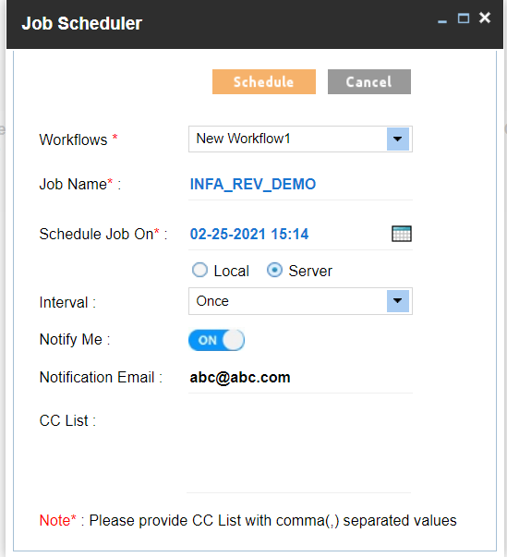

* Click on the “Schedule” button to schedule the connector run.
* The Scheduled Jobs Tab will now show the list of jobs scheduled to run.

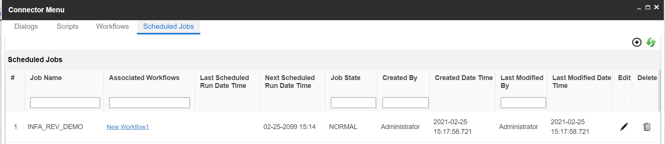

* After the successful run of a Scheduled Job, the user will receive an email notification on the status of the job run.